**Preparing Maps**

**Data Set for this Lab Sample- Superstore**

**Q 1: Prepare a Geographic map to show sales in each state**

1. **Connect to dataset**

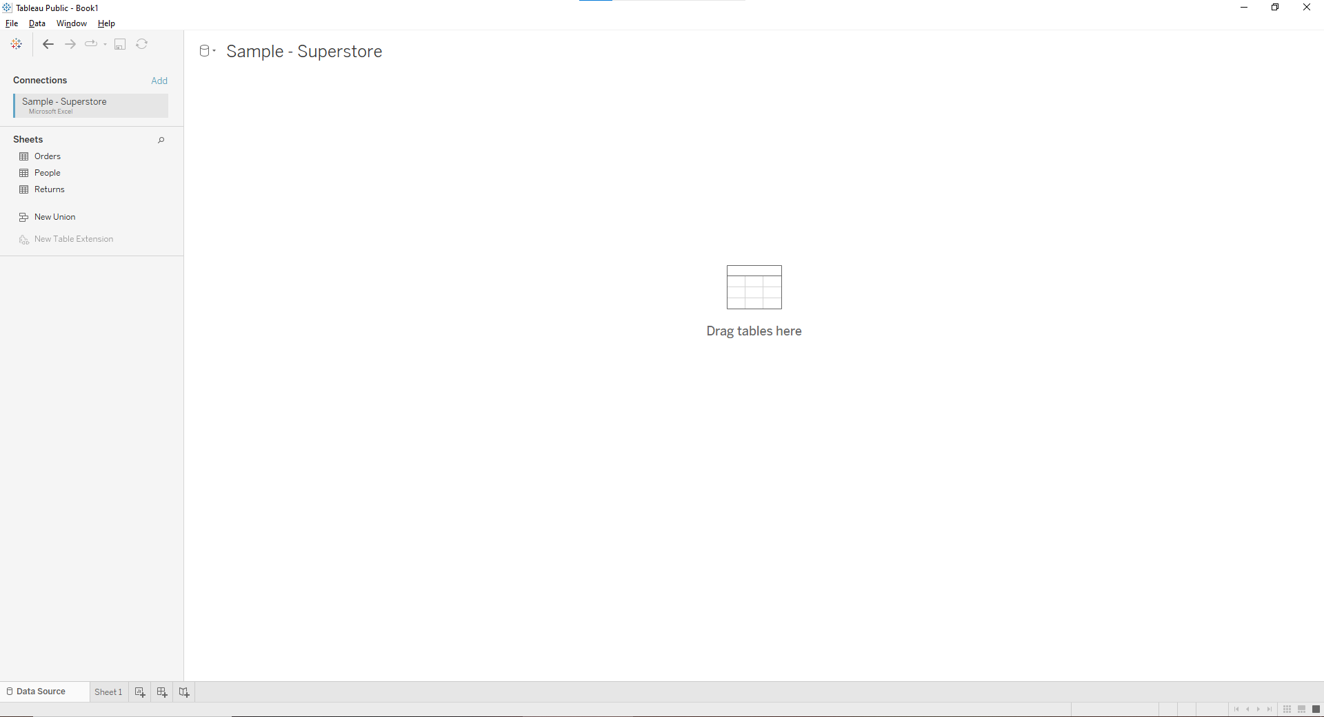

1. **Join sheets**

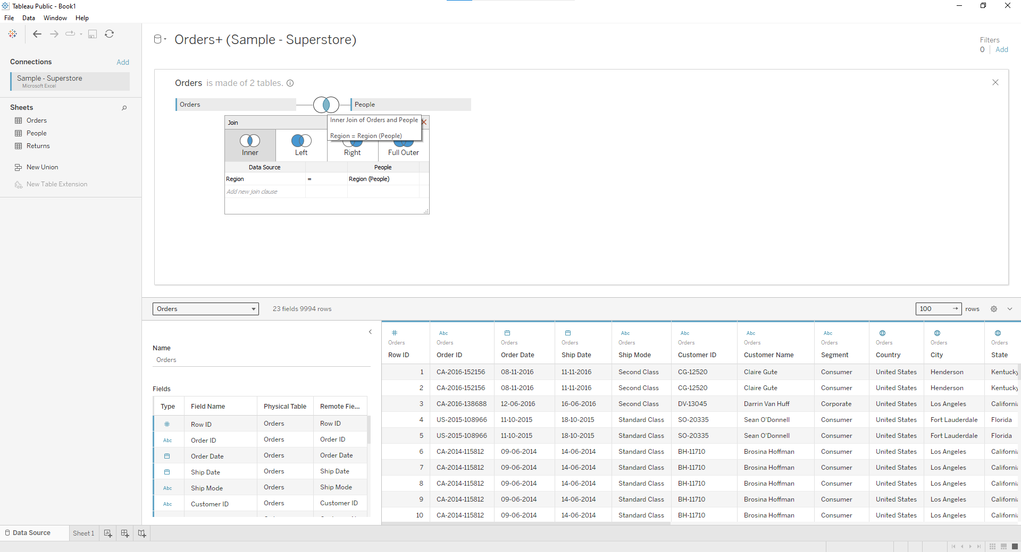

1. **Create a Geographic Hierarchy**

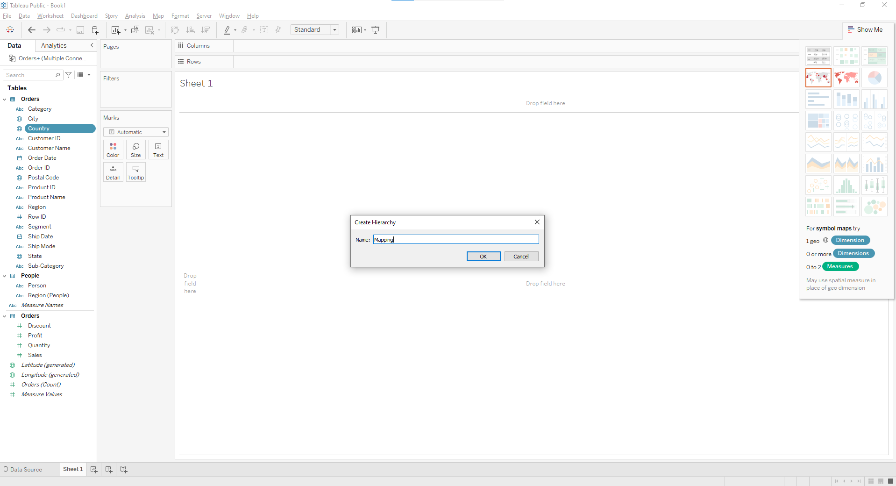

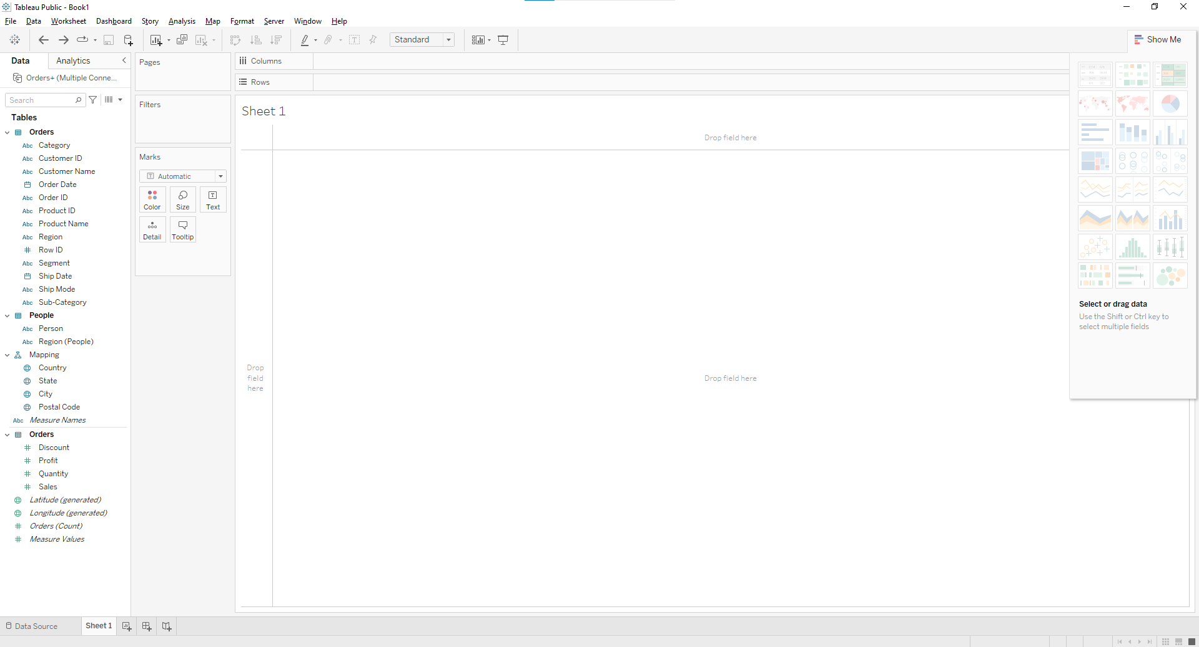

**d. Build a basic map**

**1) In the Data pane, double-click Country.**

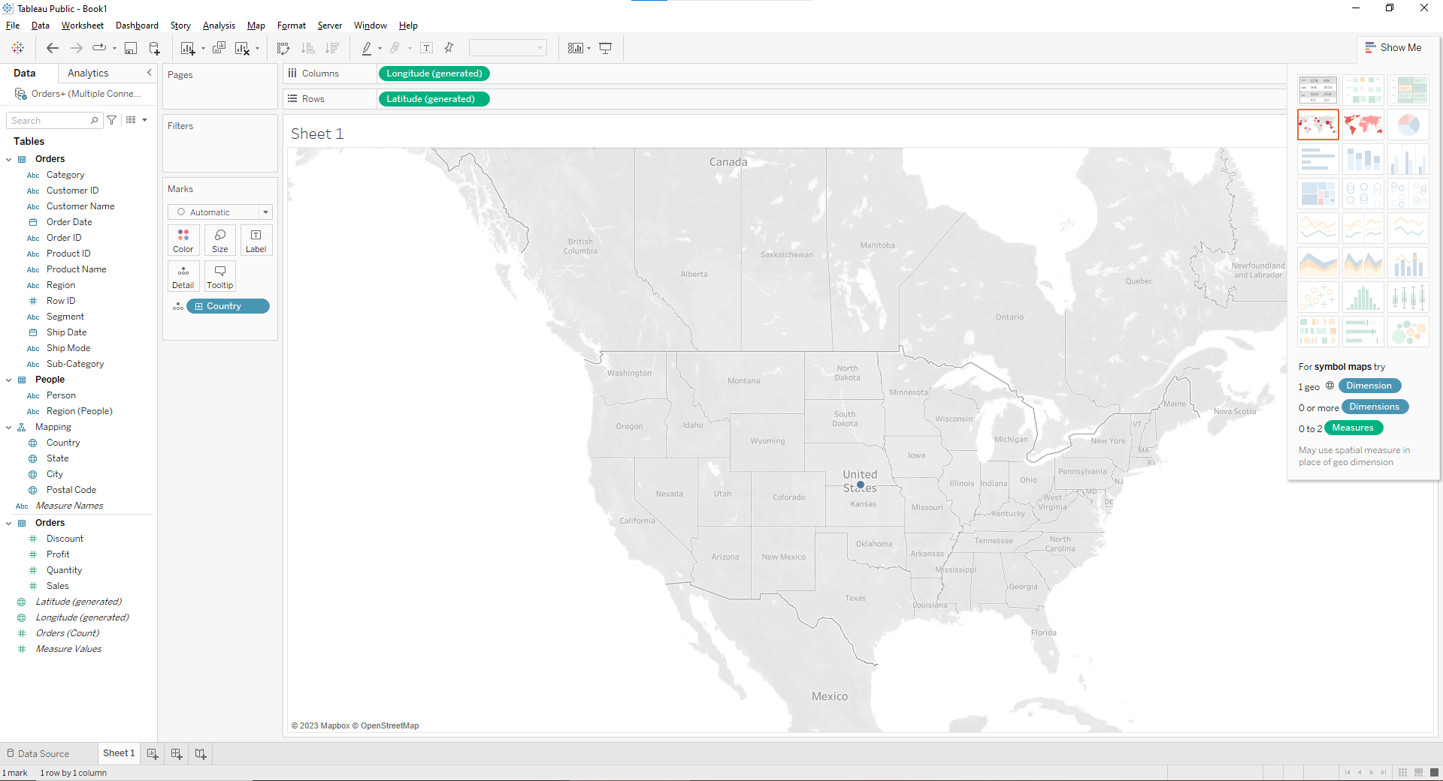

**2) On the Marks card, click the + icon on the Country field.**

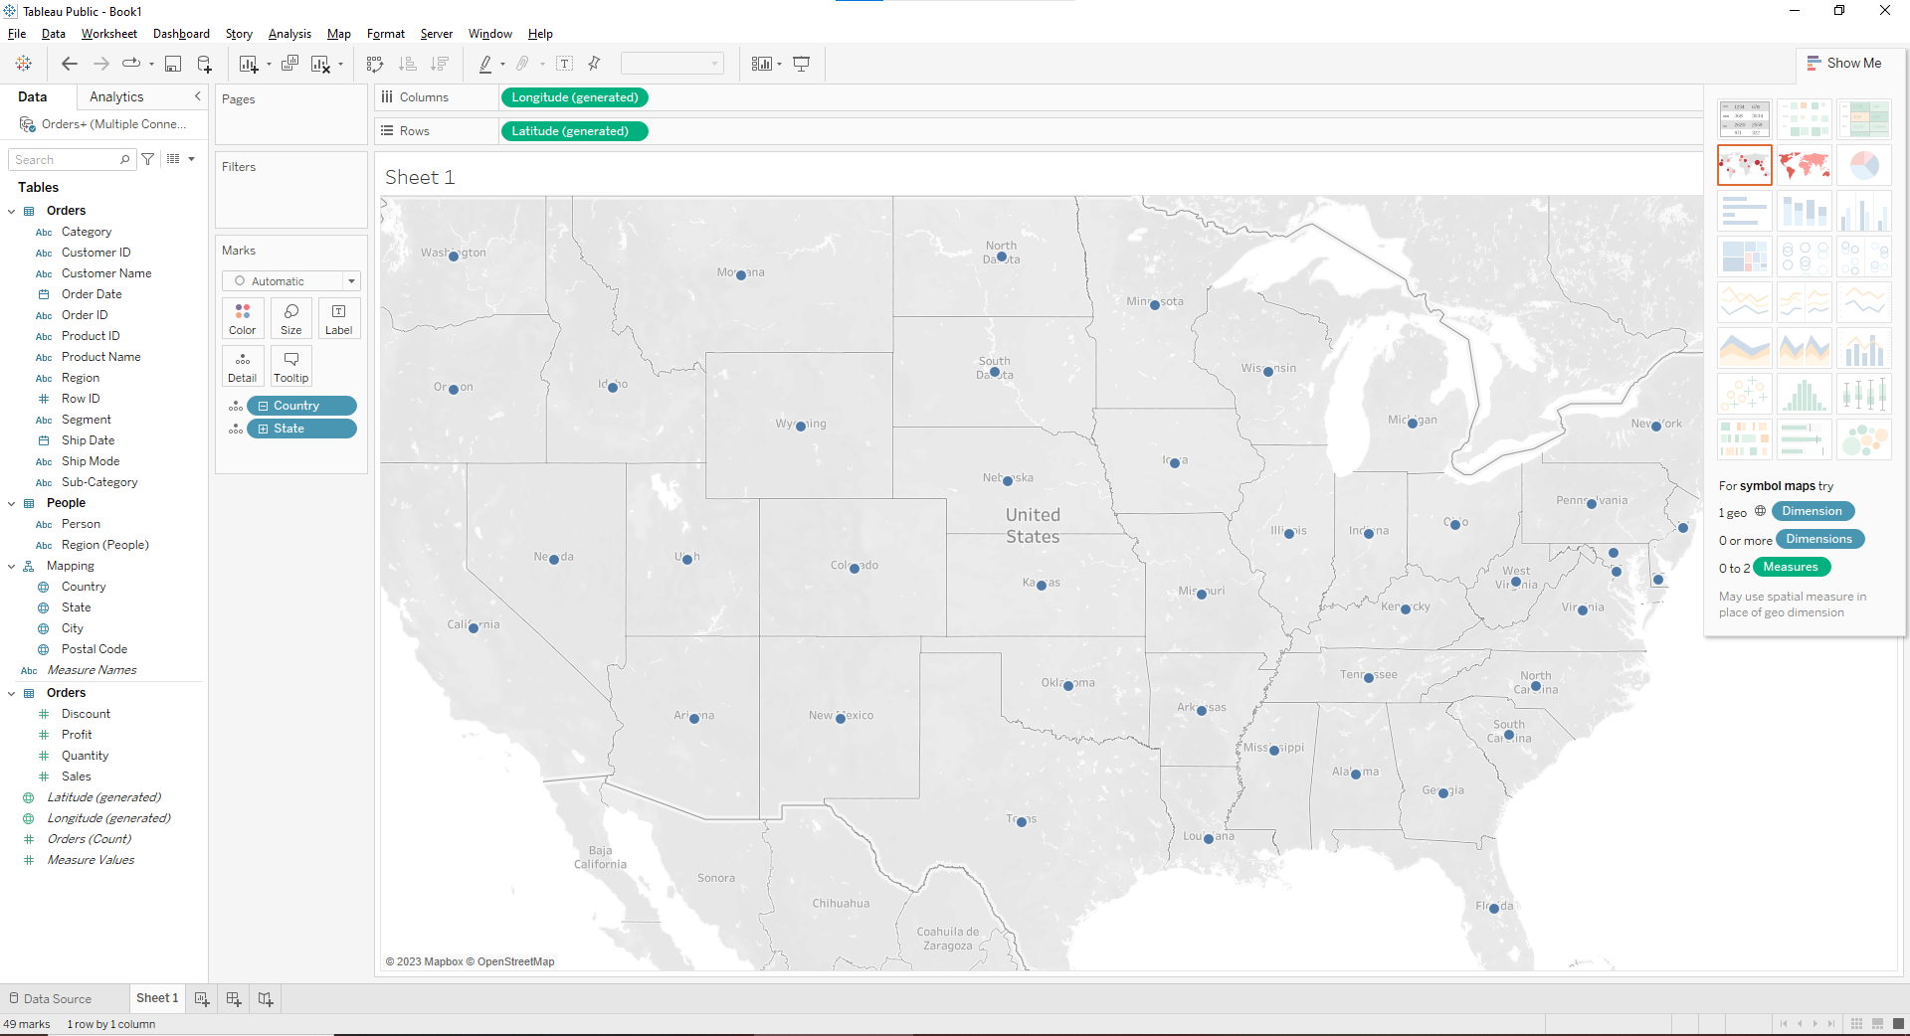

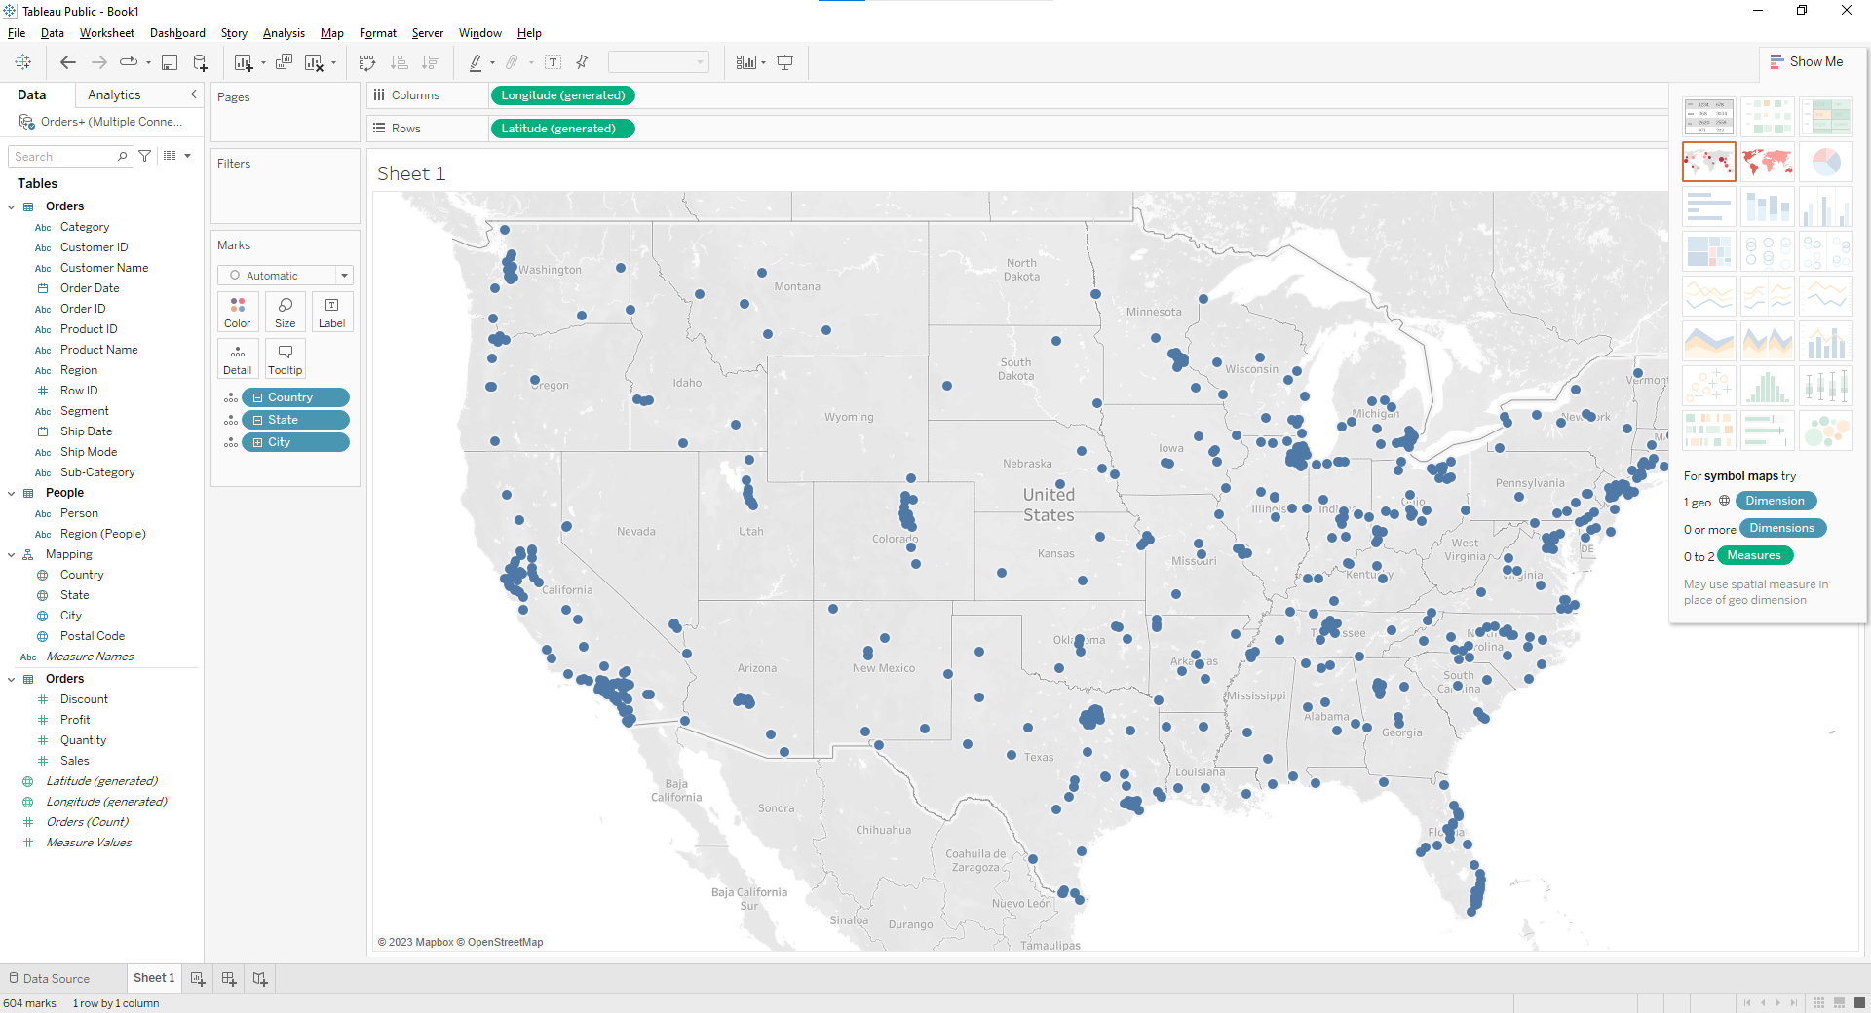

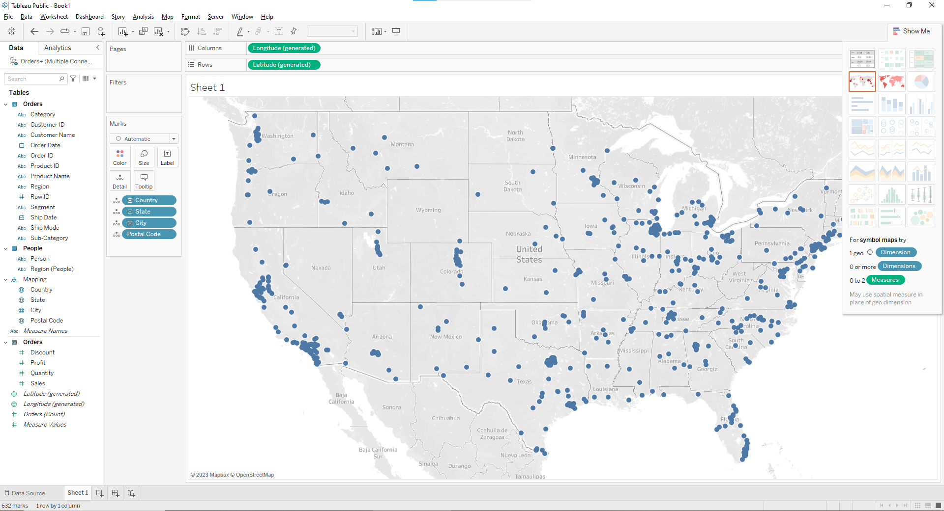

**e. Add visual detail**

**Add color**

**From Measures, drag Sales to Color on the Marks card.**

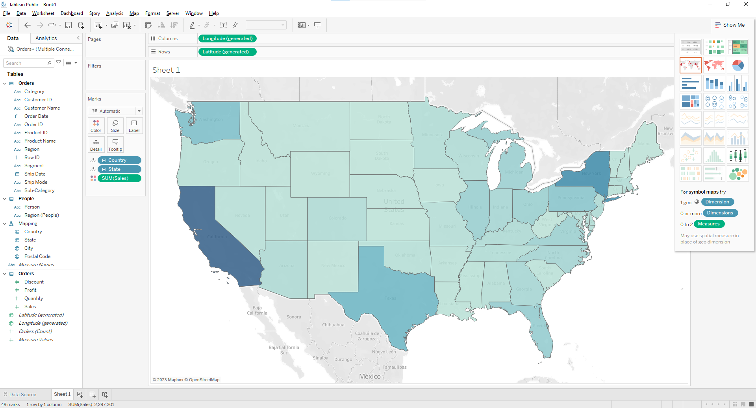

**Add labels**

1. **From Measures, drag Sales to Label on the Marks card. Each state is labeled with sum of sales. The numbers need a little bit of formatting, however.**
2. **In the Data pane, right-click Sales and select Default Properties > Number Format.**
3. **In the Default Number Format dialog box that opens, select Number (Custom), and then do the following:**

**For Decimal Places, enter 0.**

**For Units, select Thousands (K).**

**Click OK.**

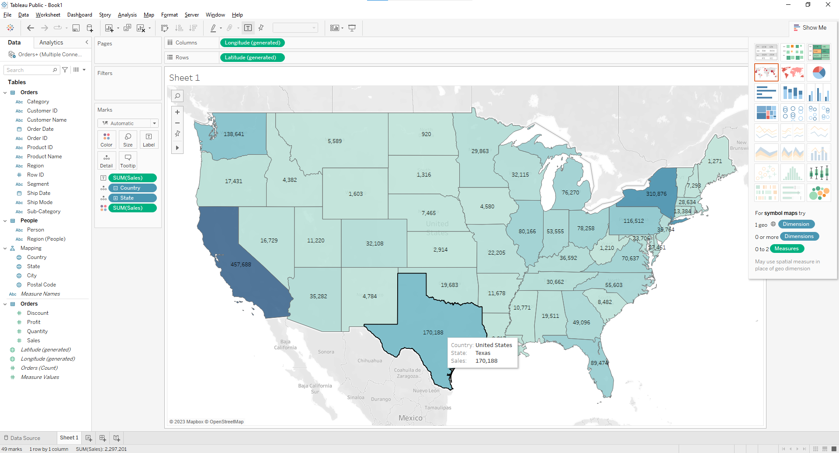

**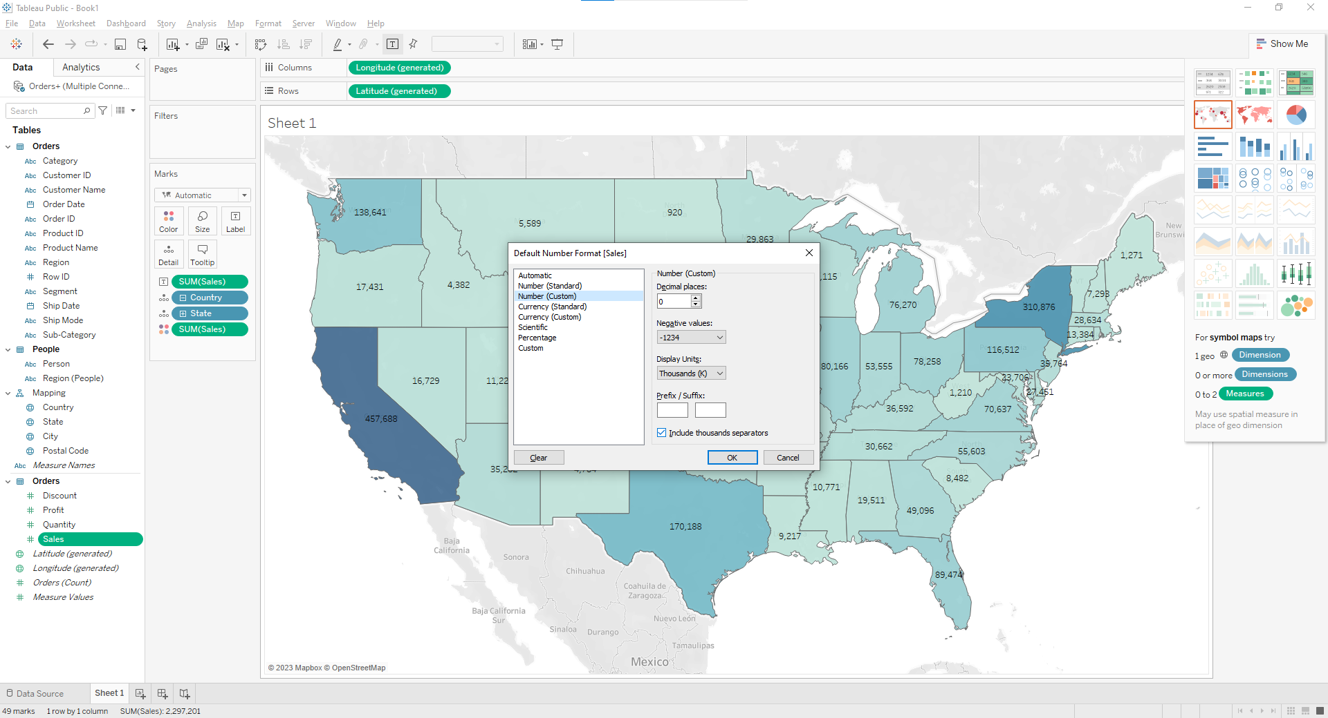  
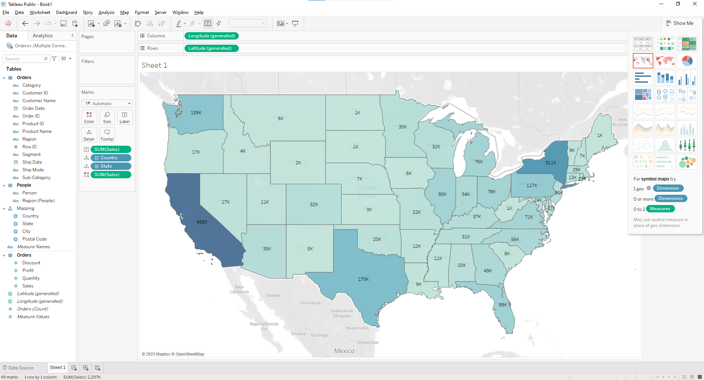**

**Q 2: Show Profit Ratio of each state as tooltip on map**

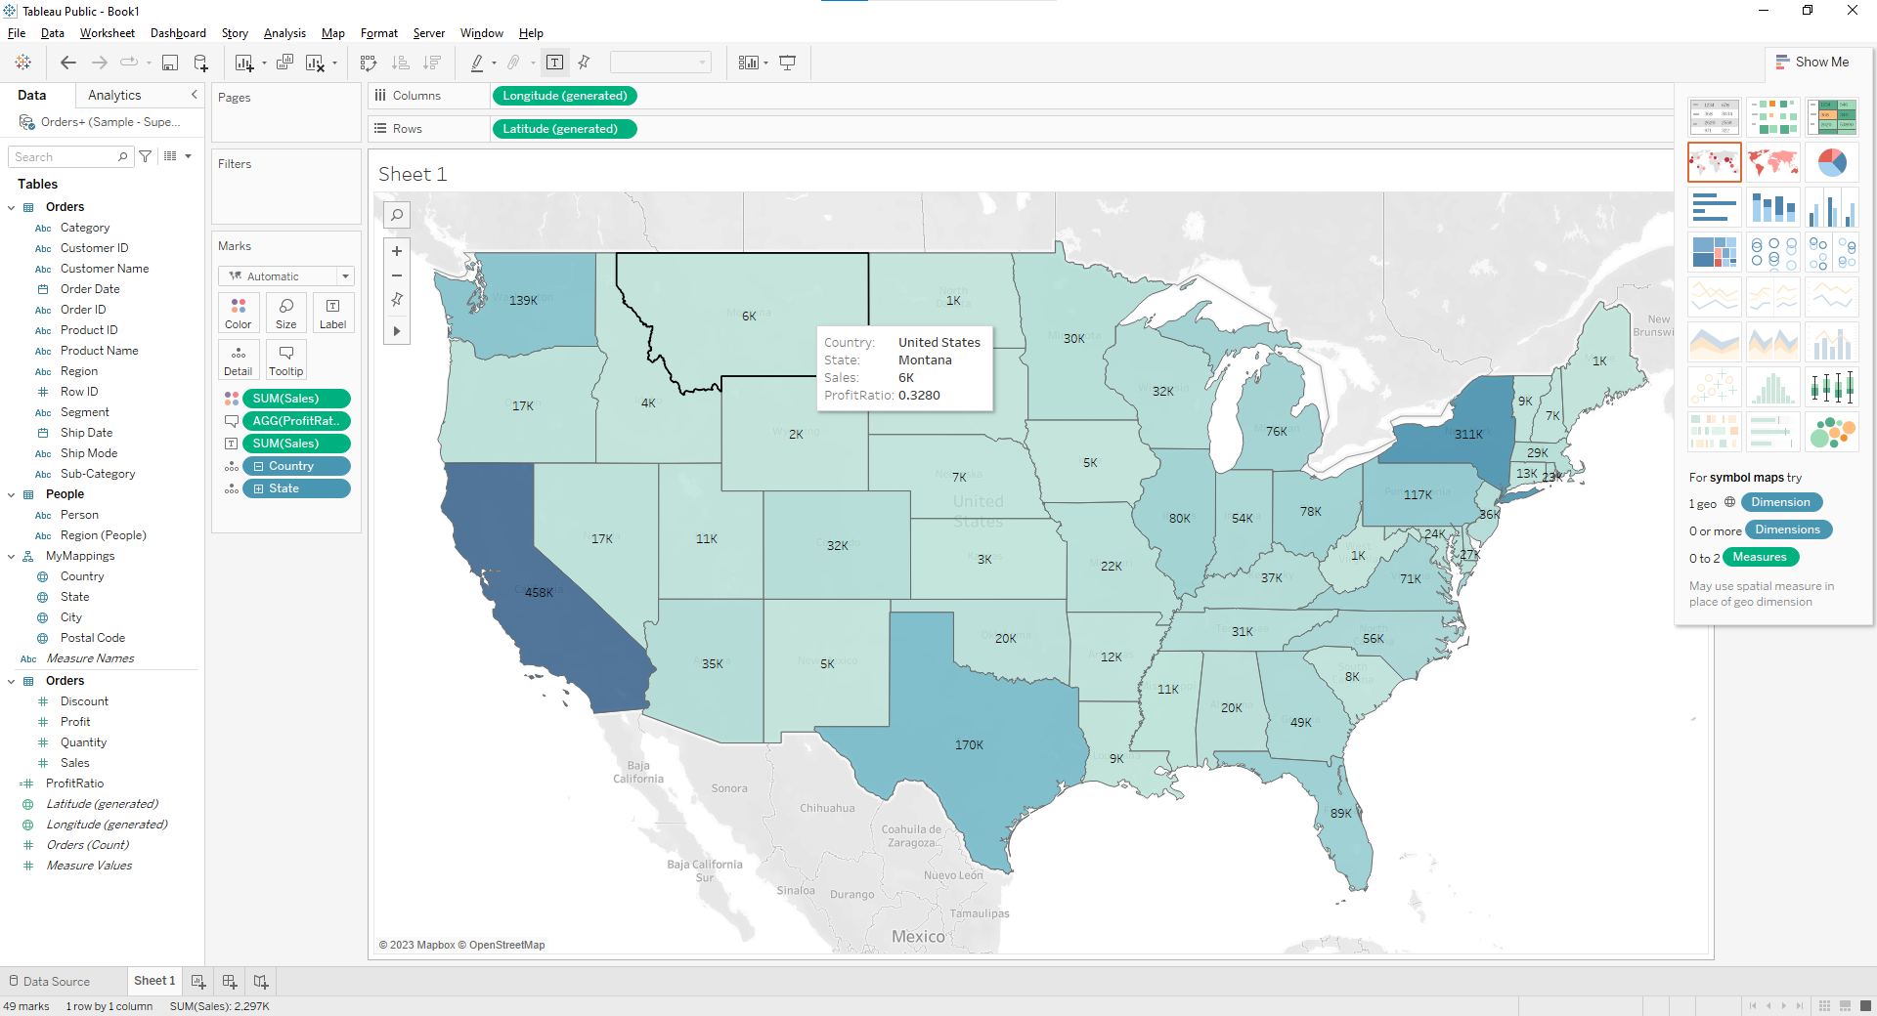

**Q 3: Show Profit ratio for Grip Envelop products**

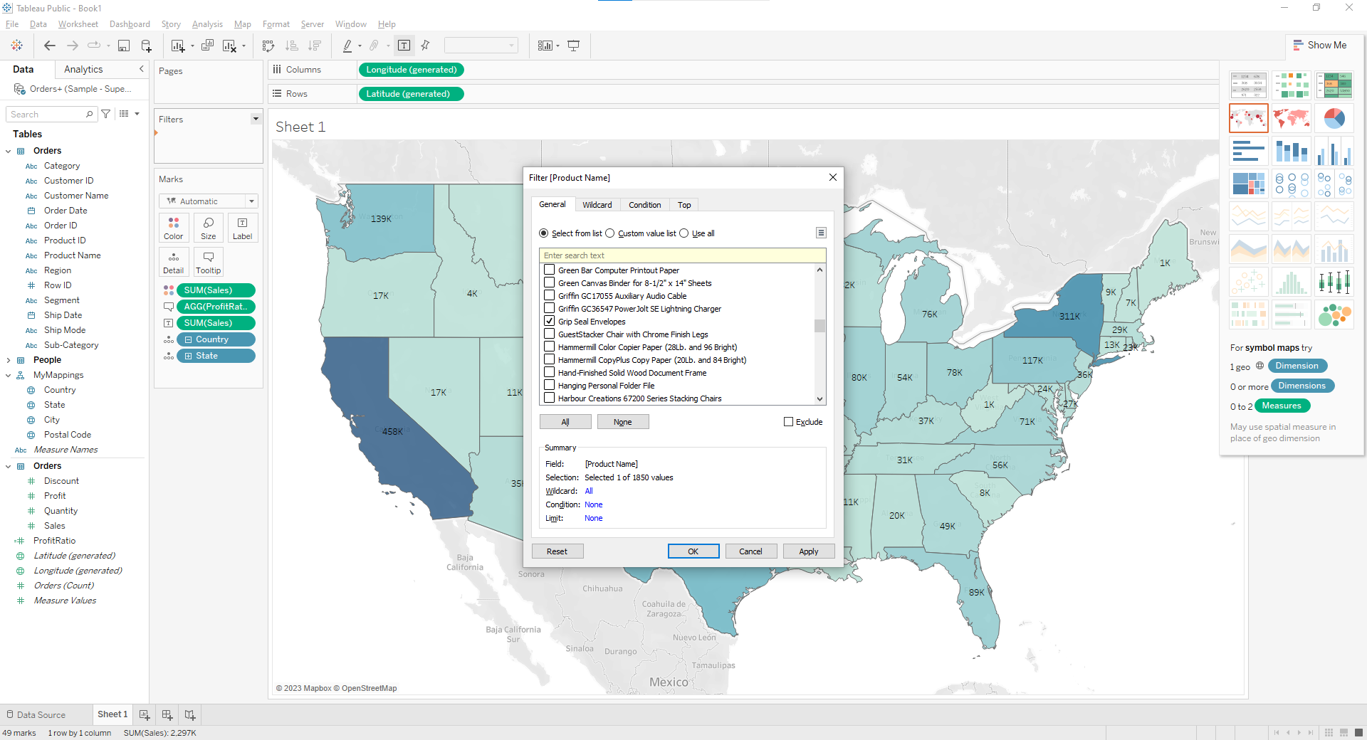

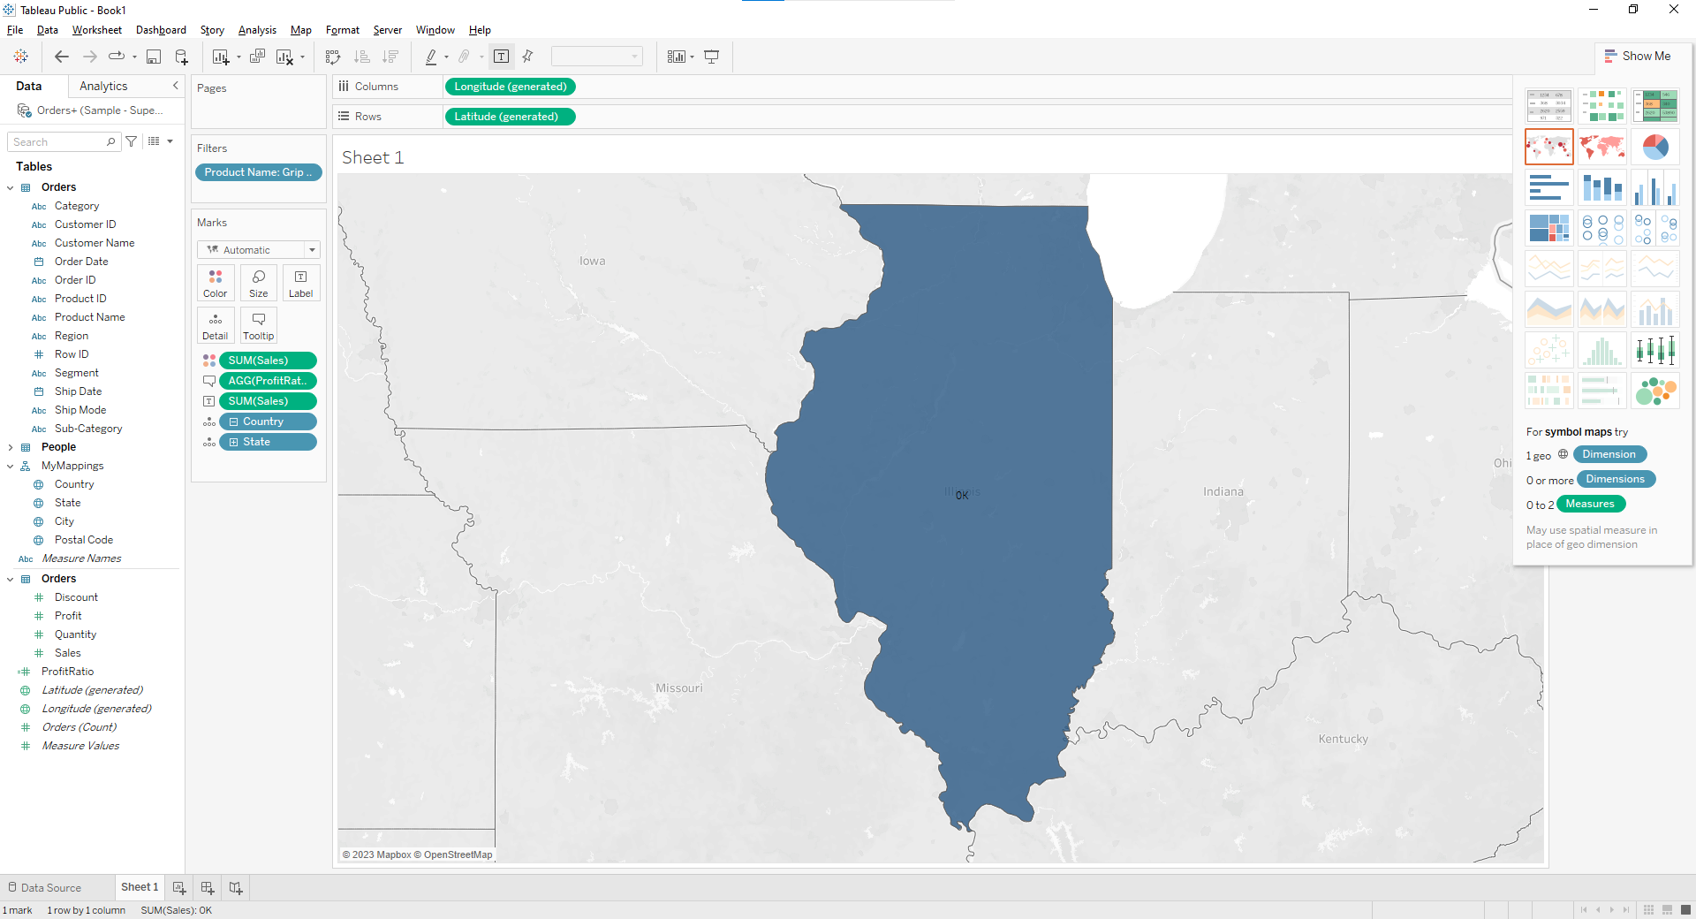

**Q 4: In the technology product category which unprofitable state is surrounded by only profitable states**

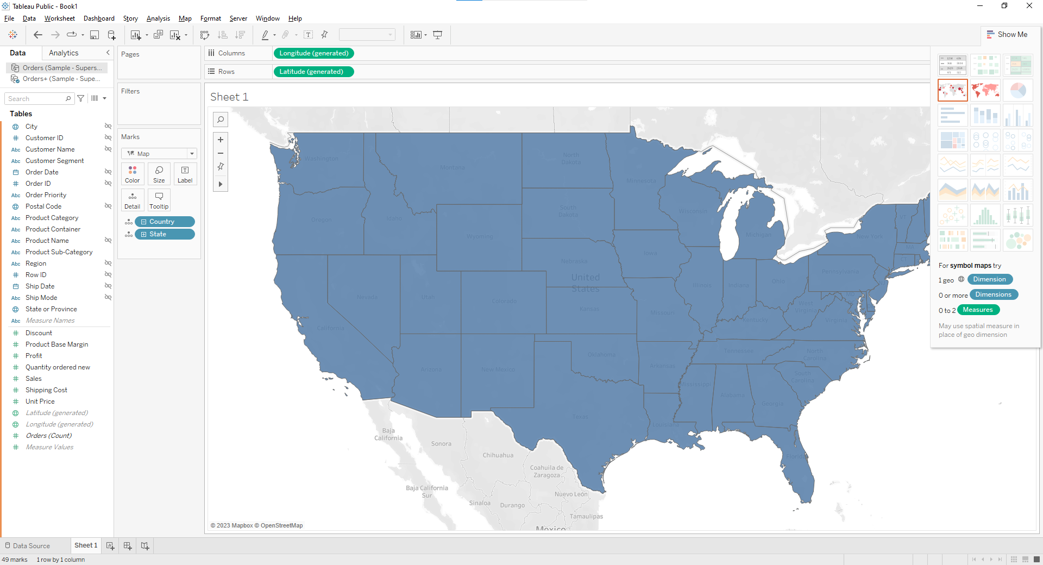

**Drag the product category on the filter shelf and select in technology.**

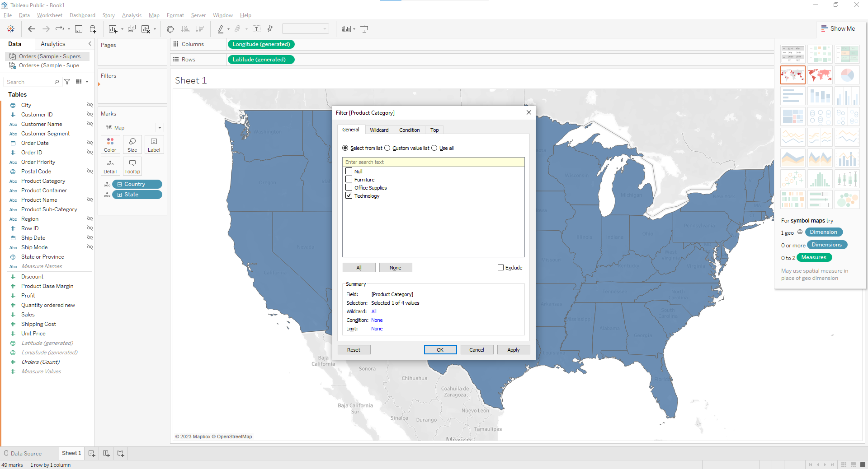

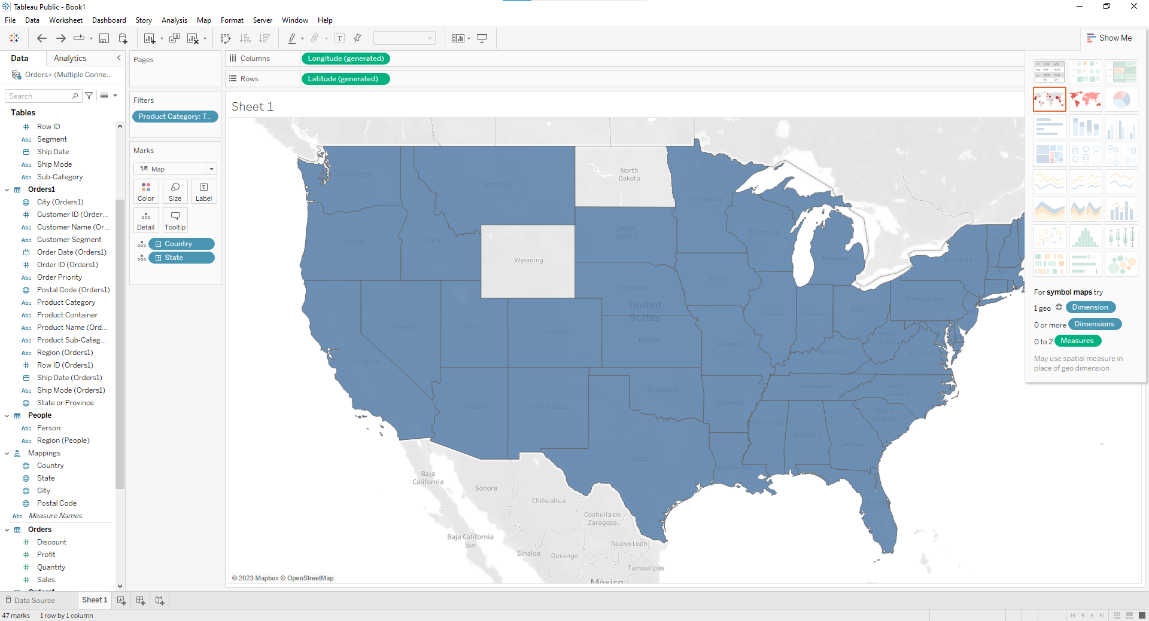

**Now Drag the profit measure to color mark**

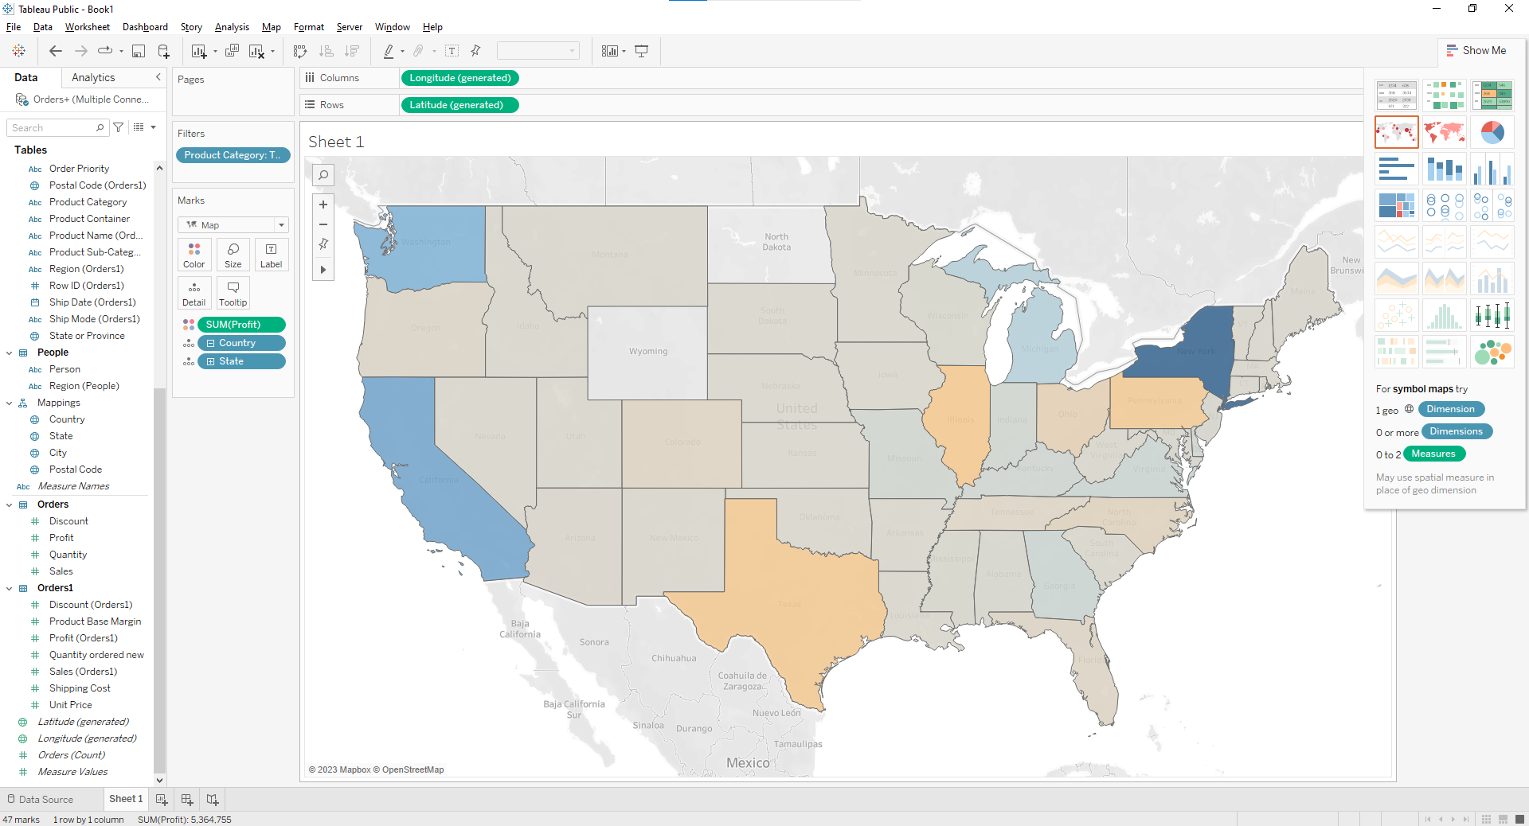

**Add profit Label.**

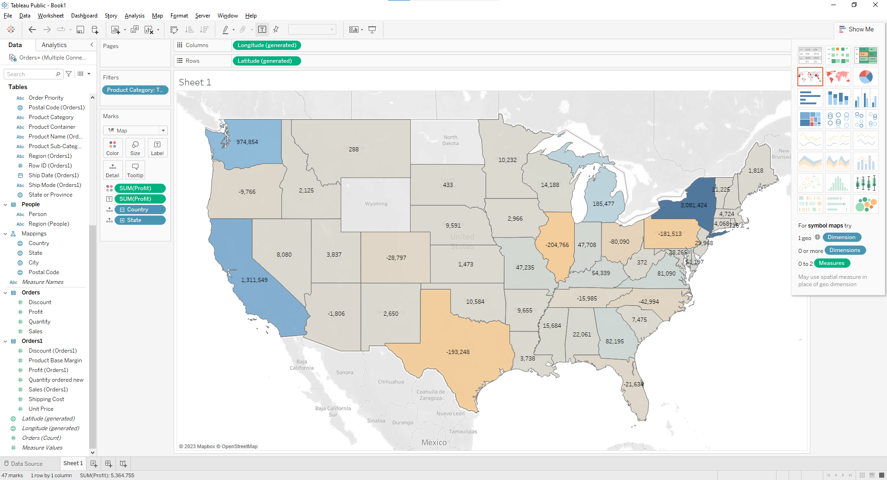

**Q 5: Which state has the worst Gross Profit Ratio on Envelopes in the Corporate Customer Segment that were Shipped in 2015**

